Lesson 16 – Introduction to Web Servers

**Introduction to Web servers:**

* Read: <https://www.fullstackpython.com/web-servers.html> (up to **Building web servers**)

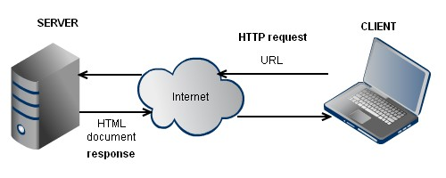

[](http://flask.pocoo.org/)**Welcome to Flask:**

* Take a quick look at this micro-web-framework for Python: <http://flask.pocoo.org/>

**Task 1:**

* Establish a simple Flask web-server on your computer.

Instructions:

1. Make sure that the Flask Python module is installed:
   * Open command line by pressing  key, writing **cmd** and pressing enter.
   * Run command >>> pip install Flask
   * 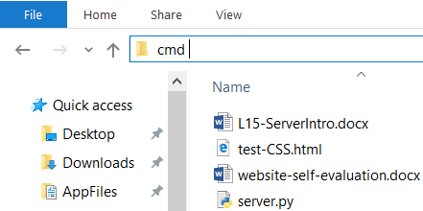Close the command line.
2. **Download** the script **server.py** from NAS and **open** it in Notepad++ (or any other editor).
3. Open the **folder** with the downloaded script.
4. Open the **command line** (from the same folder as the script is located) by typing **cmd** into the explorer **address bar** and press enter.
5. Run the command >>> python server.py

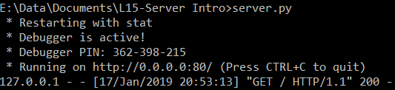

1. Open the **web browser** at an address <http://localhost:80/>
2. If everything goes well, you should see a **Hello World** message.

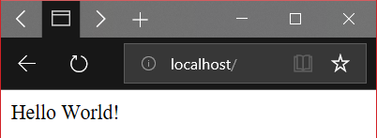

**Task 2:**

* Enable the server to serve **arbitrary HTML code**.

Instructions:

1. Look at the script **code** in Notepad++. Try to change the line return "Hello World!" to some valid HTML code such as:

return "<a href='https://gymes.edupage.org/'>GYMES</a>"

1. **Save** the modified script file.
2. Return to the **command line** and press **CTRL+C to** kill the server.
3. **Restart** the server via command >>> python server.py
4. Refresh the **web browser** at an address <http://localhost:80/>
5. If everything goes well, you should see a **link to our school website**.

**Task 3:**

* Enable the server to serve content **at arbitrary URLs**.

Instructions:

1. Read about URL routing at <http://flask.pocoo.org/docs/1.0/quickstart/#routing>

(up to **Variable Rules**)

1. Try to create these subpages:
   * "Hello subpage 1!" at URL <http://localhost:80/subpage1>
   * "Hello subpage 2!" at URL <http://localhost:80/subpage2>
   * GYMES website *inside an iframe* at URL <http://localhost:80/gymes>

**Optional:**

* Try to connect to your server from another computer.

Instructions:

1. Find out the IP address of the server PC by using command >>> ipconfig
2. [Disable](https://www.computerhope.com/issues/ch000551.htm) computer firewall or add an [exception](http://www.tomshardware.co.uk/faq/id-3114787/open-firewall-ports-windows.html) to allow incoming outside connections to the Flask app on port :80 which is used to handle HTTP communication.
3. Open the browser on the client PC and connect to <http://SERVER.IP.ADDRESS:80/>